Data Visualization Documentation
This project aims to visualize certain features of crimes in Europe and US. Crime datasets were collected from open sources, visual analytics, such as heatmaps, geographic maps, and forecast tool was used to find trends and hotspots and predict what will happen in the next years regarding the crime rates.
Photo 1- Total Crimes by Year
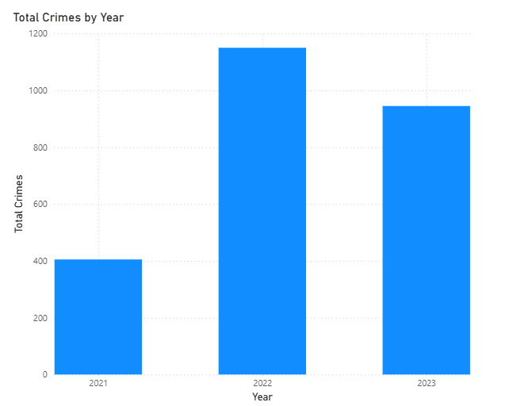
Computes the total crimes that have happened in the years 2021, 2022, and 2023, by using a bar chart; more crimes have happened in 2022 and less in 2021; 2023 has had a moderate crime level.
Photo 2- Total Crimes by Month
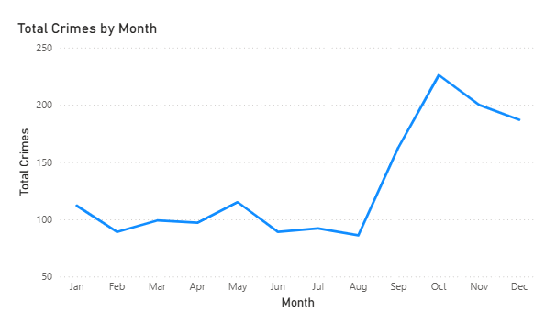
Combines total crimes of all countries by month according to the time chart.
Photo 3- Total number of crimes the previous years and the current year
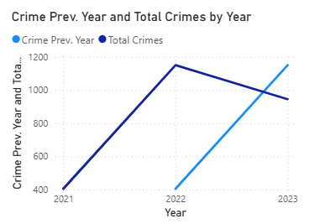
Total crimes are being compared with the previous years with a double line chart.
Photo 4- Change of total crimes by month
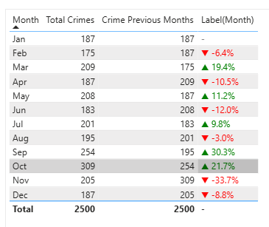
Compares by how much % crimes have dropped (in red) or risen (in green) monthly. The only exception is for Jan because it is not compared with any month since it is the beginning of the month.
Photo 5- Total Crimes by Crime Time
Divides crime time into certain regions (12:00 AM – 3 AM) by 3 hours each, and we get better insights of the time zones that have more crimes and those that have less.
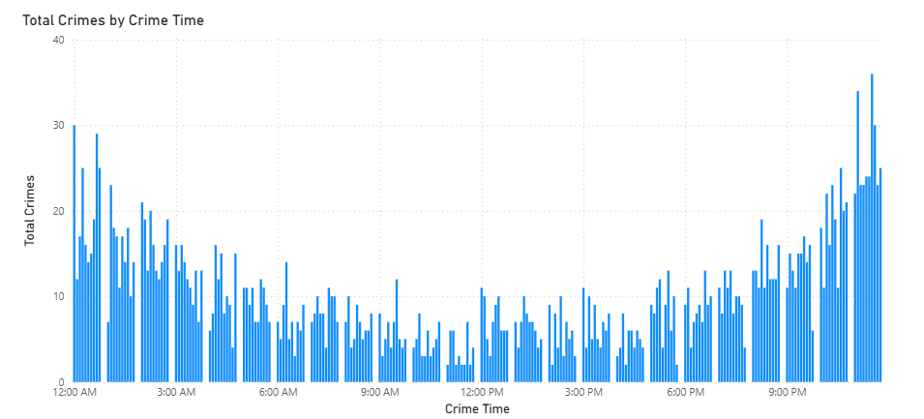
Photo 6- Crimes in different weekdays for different months
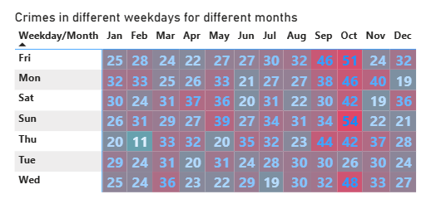
Uses a heatmap to show which day of the week and month of the year have the highest (redder ones) or the lowest (bluer) crimes.
Photo 7- Improved visualization for total crimes by time zones
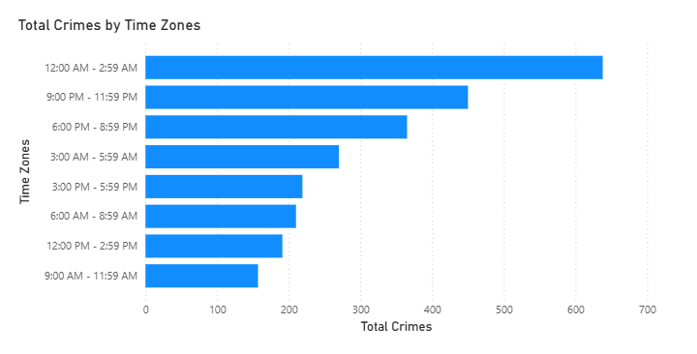
A better visualization to see which time region has the highest total crimes by using a horizontal bar chart.
Photo 8- Crimes Resolved and Crimes Unresolved
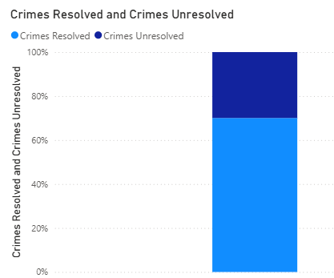
Crimes might or might not be resolved according to their type (if resolved, it is not applicable in court anymore and if yes, the penalty is given). This chart compares the resolved and unresolved crimes by using a stacked column chart.
Photo 9- Total Crimes by Crime
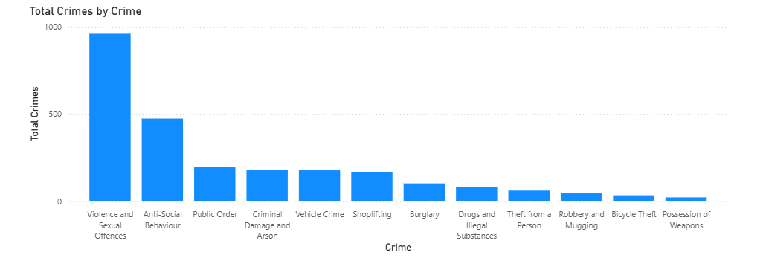
Crime type shows what crime was committed, and which crime type was the most occurring and which the least.
Photo 10- Sum of People Involved by Country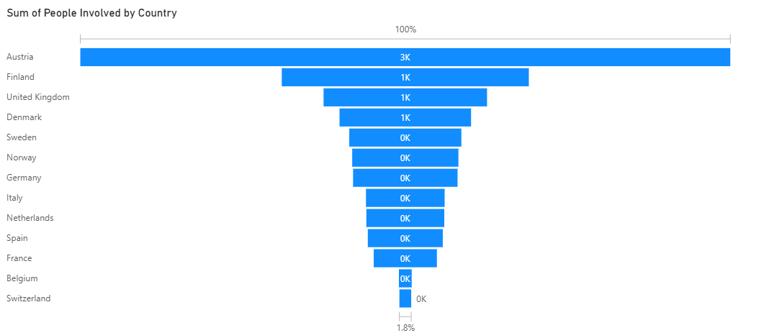
The funnel chart displays how many people have committed the crime for each country cumulatively (for example, if Switzerland accounted for 10% of the people and another country 20%, the other country will show 20%; 100% does not show the % of the people/ the entire people who committed the crime for that country).
Photo 11- Sum of Resolved by Country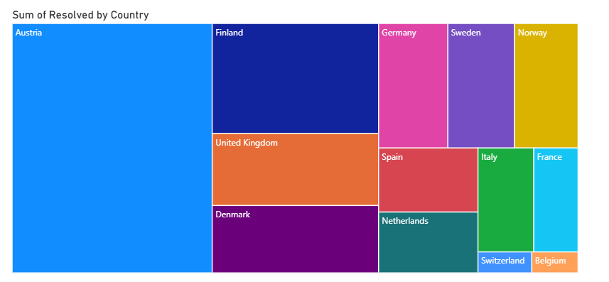

The treemap shows the countries with the most resolved crimes and those with the least.
Photo 12- Crimes Resolved and Crimes Unresolved by Country and Crime Year
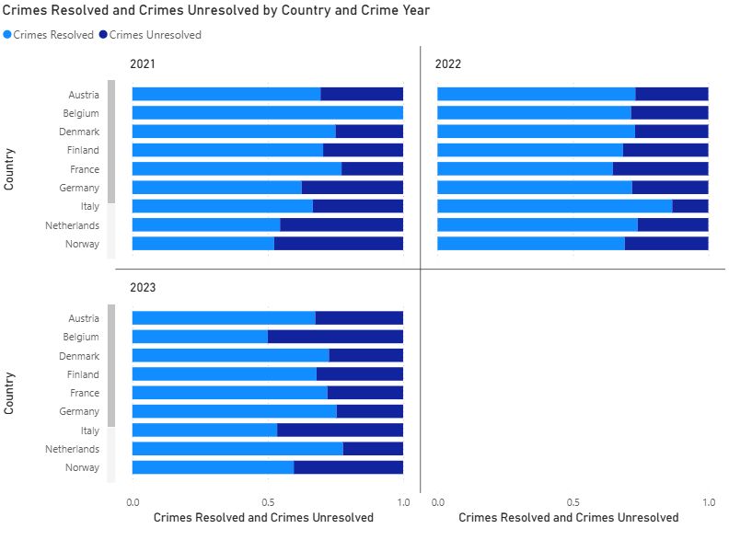
For each country, the resolved and unresolved crimes are compare across 3 years.
Photo 13- Crimes Unresolved by Crime Year
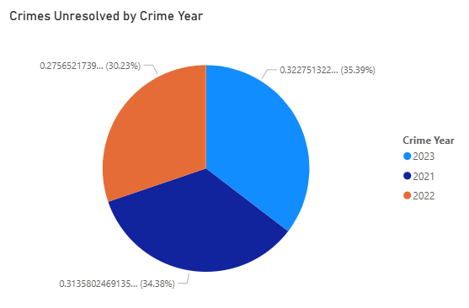
For the three years the number of unresolved crimes for each crime year is calculated.
Photo 14- Crimes Resolved by Crime Year and Comparison Between Resolved and Unresolved Crimes in a tabular format
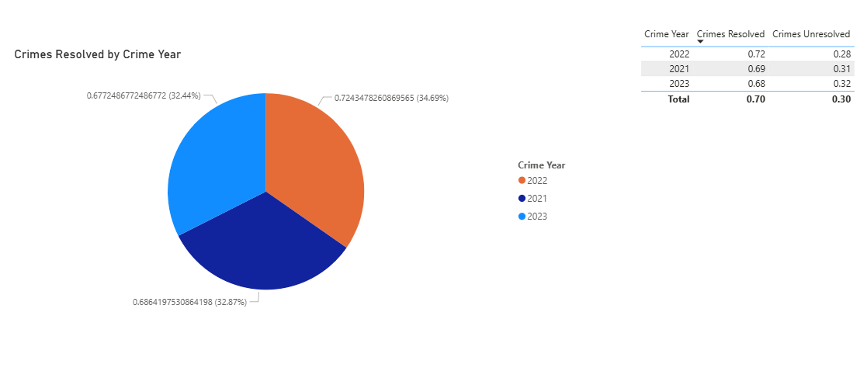
The pie chart shows the crimes resolved by the three crime years (which has the most crimes resolved and which the least crimes resolved), and the table compares the unresolved and resolved crimes between each year.
Photo 15- Sum of People Involved by Moment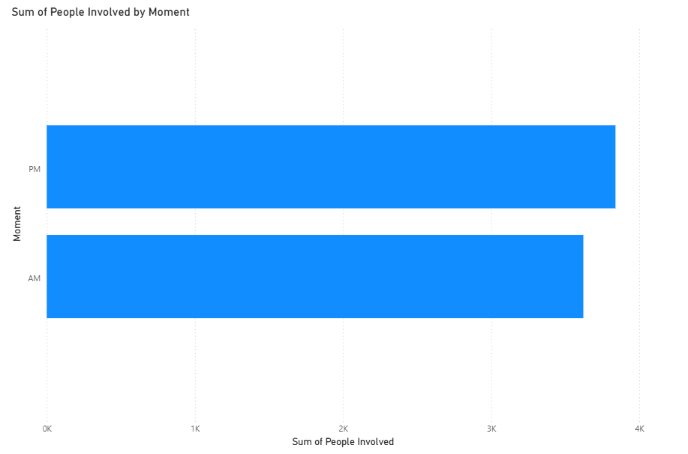
Shows how many people were involved at AM and PM (broader moments than in 3 hour ones).
Photo 16- Comparison of Sum of Assault/Murder/Rape/Urban Populations across state and for each state
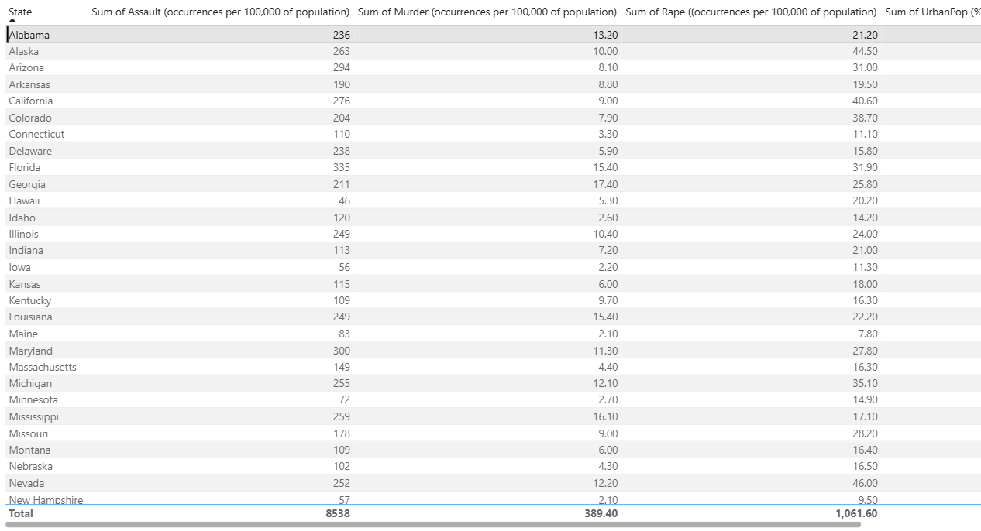
Sum of Assault, Murder, Rape are given in occurrences for 100,000 of population, but Sum of UrbanPop represents the percentage of the population that lives in each of these areas.
Photo 17- Crimes in the US and their frequency in a stacked column chart
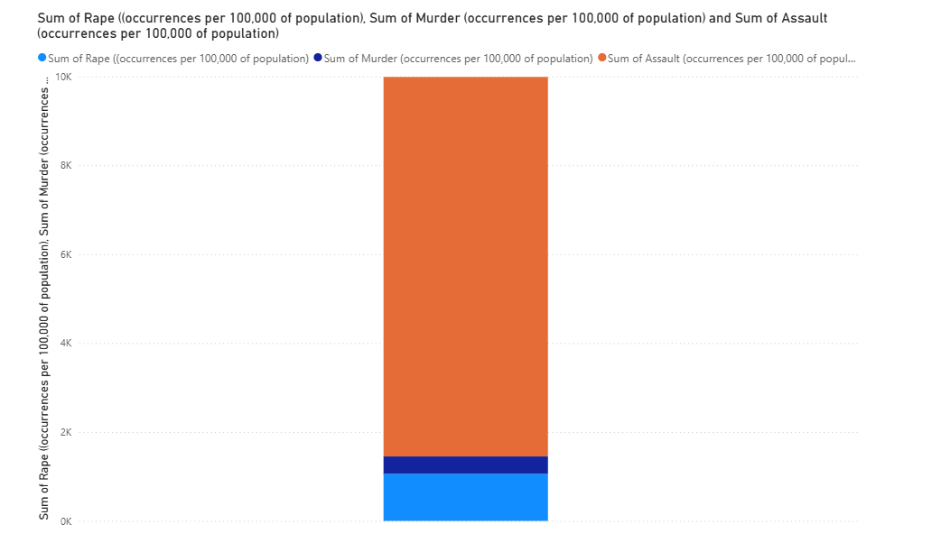
Which crime occurs more than the others in the US is compared here.
Photo 18- Visualization of Sum of Assault/Murder/Rape/Urban Populations across state and for each state 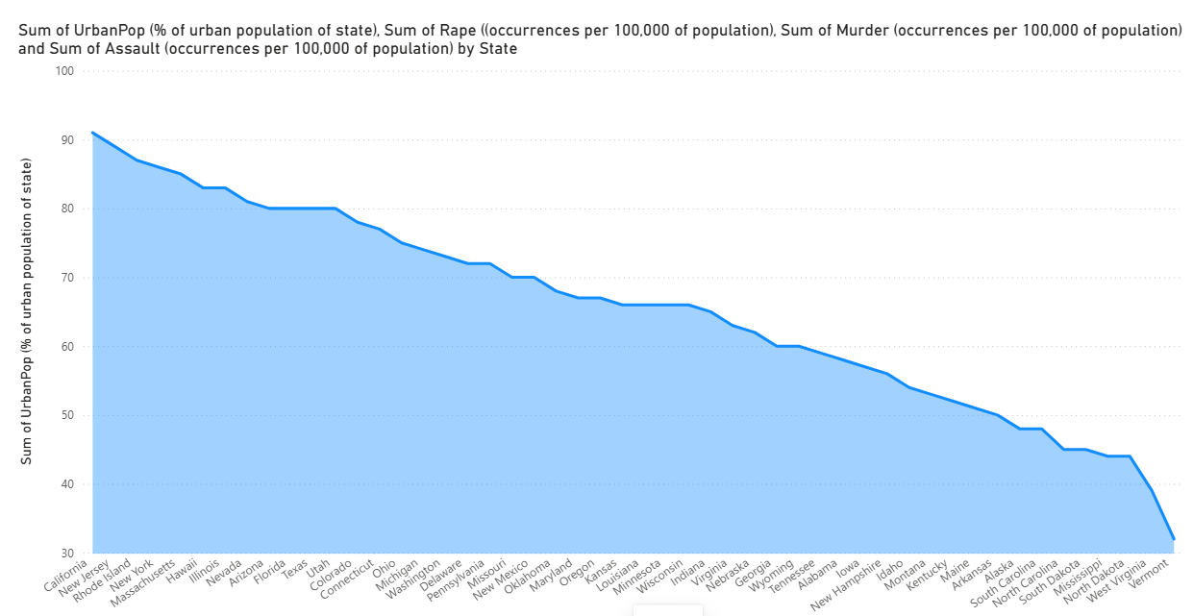
For each state, the assault/murder/rape/urban populations are measured to see what state has the highest for each of the crimes combined, but the data is not entirely numeric, but also visual.
Figure 19- Sum of Rape (Sexual Assault) and Sum of Assault (Physical Assault) by State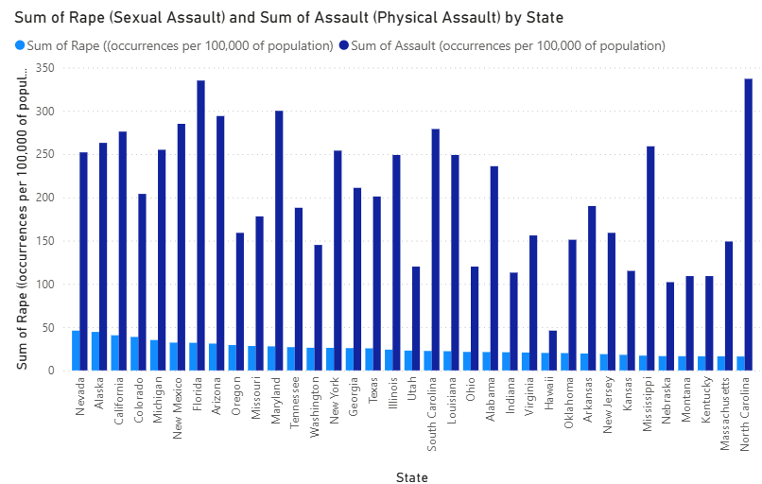
For each state, physical versus sexual assault (rate) is compared to see which of those is the most prevalent.
Figure 20- Sum of Urban Population by State
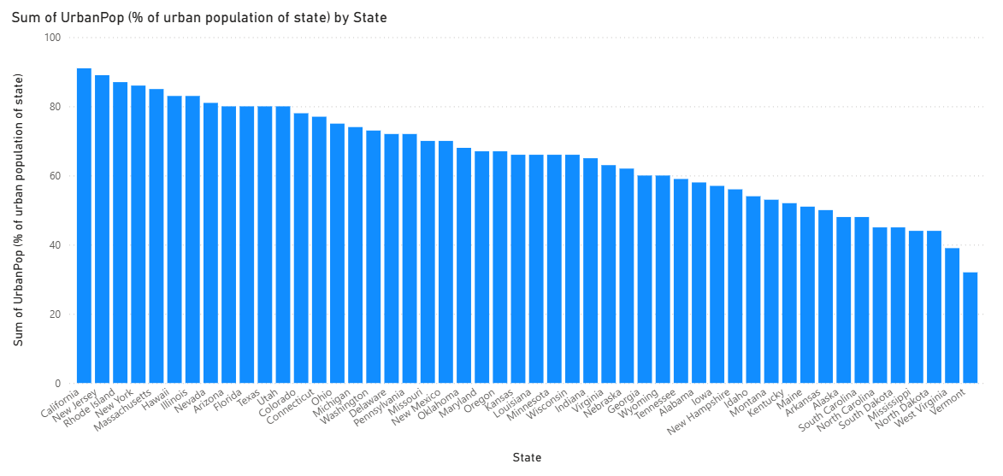
States are compared across each other to see which state is the most urban one by using a simple and vertical bar chart.
Figure 21- Sum of Murder (occurrences per 100,000 of population) by State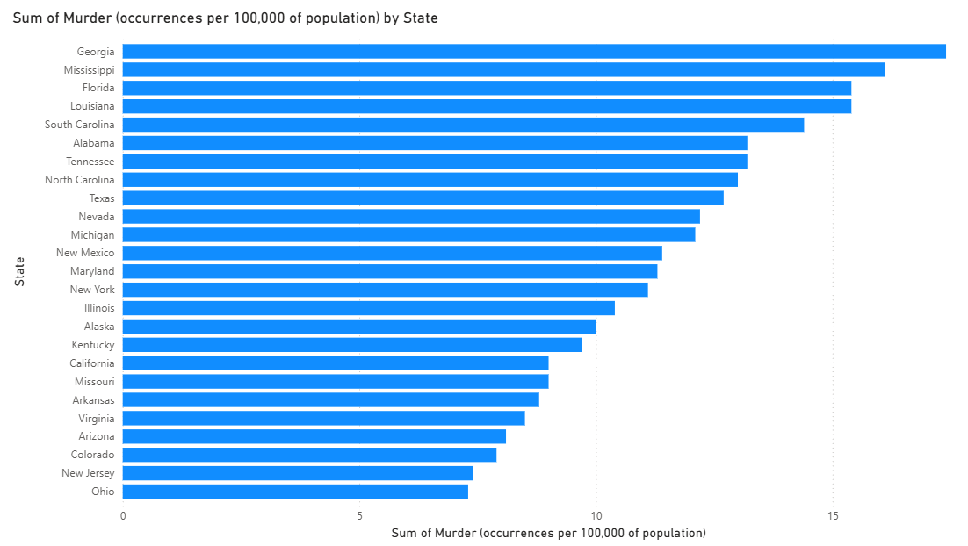
It shows what country has the highest and lowest murder rate per 100,000 of population.
Figure 22- Sum of Assault (occurrences per 100,000 of population) and Sum of Murder (occurrences per 100,000 of population) by State
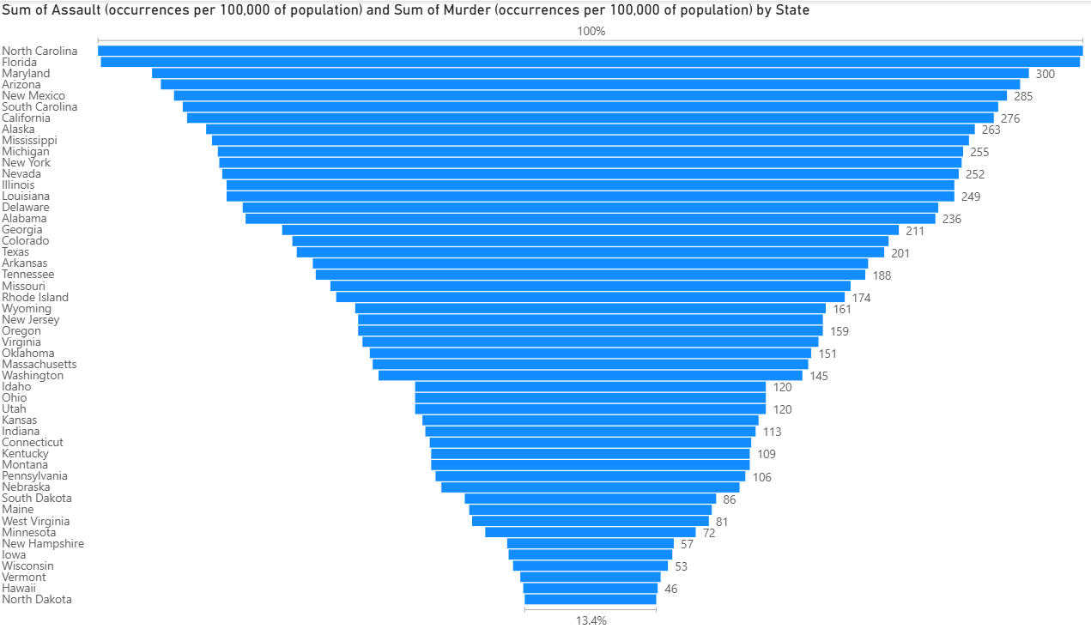
Assault, both physical and sexual, has been combined for all the states in a funnel chart.
Photo 23- Total Crimes by Year Prediction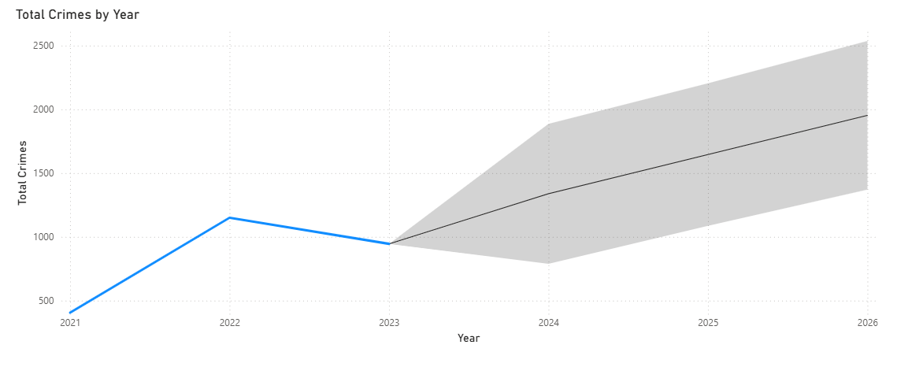
The last year where crimes were recorded was 2023, so the total number of crimes are being predicted for the next three years.
Photo 24- Crimes Resolved and Unresolved by Crime Year Prediction
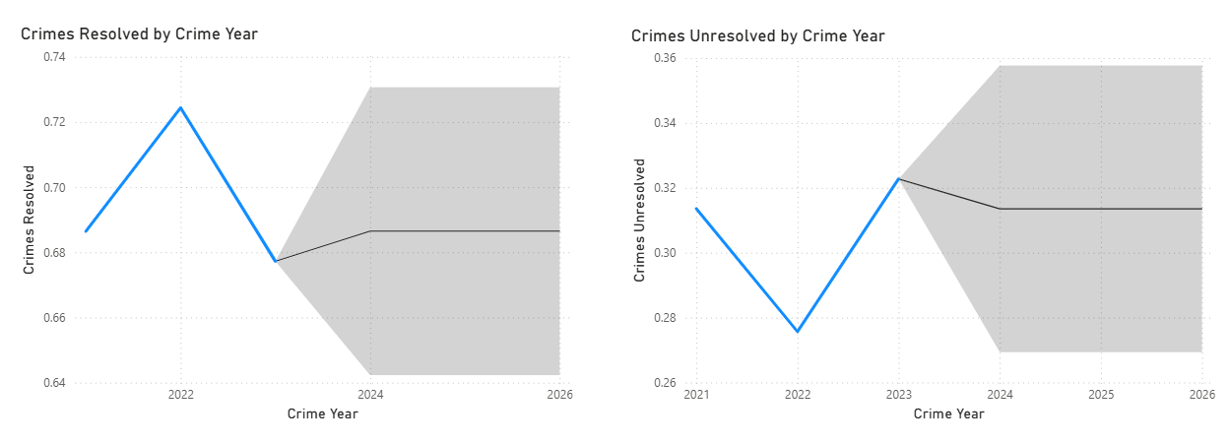
Is the number of crimes that are not resolved or the crimes that are resolved increasing or decreasing in the next three years? These graphs answer this question.
Photo 25- Visualization of countries in Europe that were studied for crimes
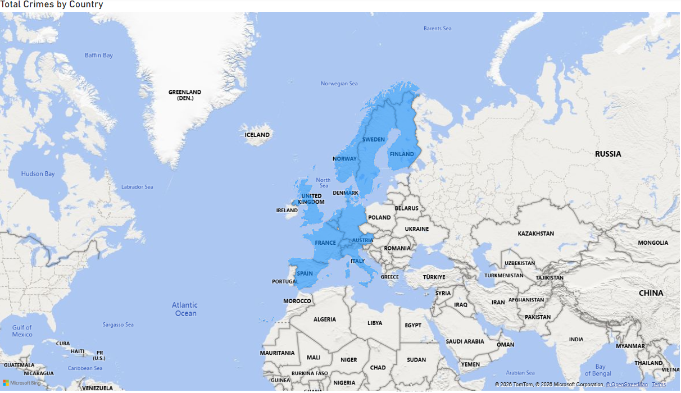
In Europe, not only in the US, what are the countries that were studied for the crime presence?
Findings (based on photos 1-25)
- The year with the highest number of crimes was 2022, and 2021 was the one with the least, while 23 showed a moderate crime level.
- October was the month that noted the highest crimes, and August was the lowest, although August-September-October with the steepest rising gradient.
- 2022 had approximately 775 more crimes than 2021, based on the line charts, and 2023 approximately 200 less than 2022.
- Based on the table of the changes in total crimes by month, September had the highest increase, while November the largest decrease.
- Most crimes happen at night, when there are no people around, rather than in the day, and the horizontal bar graph and the vertical one show that the period with the highest crimes is 12:00 AM up to 2:59 AM, and this is expected due to less people being on the streets in this time interval. Therefore, crimes at PM moment are more frequent than at AM ones.
- The day of the week with the highest crime is Sunday and its corresponding month October; the opposite is for Thursday and February.
- The ratio unresolved crimes to resolved ones is 29.96% to 70.04%, which means that most crimes can be resolved.
- The most prevalent crime is Violence and Sexual Offences, the least one Possession of Weapons.
- The country with the highest crimes is Austria, the least murders Switzerland.
- The country with the most resolved crimes is Austria and the one with the least Belgium. Correlation doesn’t imply causation because highest crimes do not mean that they are unresolved ones.
- The number of unresolved crimes is slightly increasing from year to year, and resolved ones slightly decrease, as per the pie chart that shows the crimes resolved by crime year.
- In US, physical assault is the crime that appears most, followed by rape, and then murder.
- The most urban state is California and the least one Vermont.
- Georgia is the state with the most murders and North Dakota with the least ones.
- According to predictions of the next three years, the total number of crimes will show an increasing trend, the resolved ones will increase from 2023-2024 (the last recorded year was 2023 so we calculate until 2026) and then remain stable from 2024-2026; the only difference of the unresolved ones is that the unresolved ones will decrease from 2023-2024.

Crime Prevention Strategies based on Findings
Especially on weekends, at October, at time intervals of 12:00 AM to 2:59 AM, for unresolved crimes, and for Violence and Sexual Offences, in Austria/Georgia:
1. Target Hardening - Improving the security of your premises from being accessed by the offender. Fitting better locks for doors, windows, sheds and any other building. Setting up stronger passwords for protecting yourself from hackers. Improving the security of your premises from being accessed by the offender.
2. Target Elimination - Making sure the target is no longer visible. Avoiding placing any of your items visible from outside, such as laptops, phones, keys, and bags. Parking your car in the garage, if you have one, and not displaying your possessions inside. Avoiding posting anything on social media as it can be used against you.
3. Minimizing the Means - Taking away objects which might assist in committing the crime. Not storing tools and ladders in the garden, and tidying up any rubble/bricks. Keeping the wheelie bin out of reach, as it may serve as a climbing device or assist in carrying things around Ensuring the tidiness of any bricks and rubble.
4. Reducing the Payoff - Reducing the profit the criminal can make from the offence. Security marking your property. Marking your property in such a way that others will not want to buy from the thief. Not buying property you believe or suspect to be stolen.
5. Strengthen Anti-Violence Social Norms & Peer Relationships - Violence can be reduced by promoting positive social norms and relationships through outreach, trusted mediators, family support, tailored services, and interventions that prevent retaliation.

